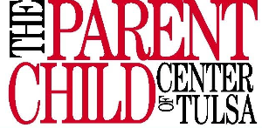

Shaken Baby Syndrome Hospital Outreach Program

Shaken Baby Syndrome (SBS) is the leading cause of death in abusive head trauma (AHT) cases. An estimated 1,200 to 1,400 children are injured or killed by shaking every year in the United States. Actual numbers may be much higher as many likely go undetected. Massachusetts Citizens for Children estimates that for every infant injured by Shaken Baby Syndrome up to 152 other infants also suffer some degree of harm. The National Center on Shaken Baby Syndrome reports that every six hours in the United States an infant becomes the victim of violent shaking. Up to 35% of these victims die from their injuries and 80% who survive suffer permanent life-long disabilities such as blindness, deafness, cerebral palsy, mental retardation, behavioral disorders and impaired motor and cognitive skills. Many survivors require constant medical or personal attention, which places tremendous emotional and financial strain on families and society. Medical costs associated with initial and long-term care for these children can range from $300,000 to $1,000,000 a year.
In Oklahoma, in SFY ‘07, 37 children under one year of age were confirmed to suffer severe Abusive Head Trauma and 8 of them died. Of the 37 children 20 were from Shaken Baby Syndrome. It is estimated more than 3,000 Oklahoma children are shaken each year.
The Parent Child Center is committed to educating the community about Shaken Baby Syndrome and hopes one day to be able to reach every birth mother and father with this information.

